**INTEGRATION TESTCASES REPORT**

Following are the testcases:

**Testcase 1:** server starting at boot.

**A screenshot of a computer

Description generated with high confidence**

**Testcase 2:** connection established, client has been started and listening to port 8021.

**A screenshot of a computer

Description generated with high confidence**

**A screenshot of a computer

Description generated with high confidence**

**Testcase 3:** Sever side concurrency.

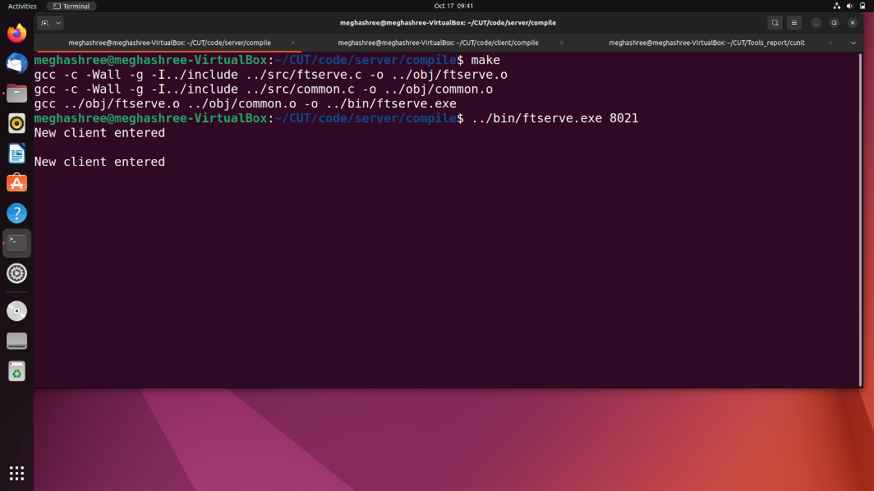

**Text

Description generated with very high confidence**

**Testcase 4:** Client authentication and using ls, pwd, get, put and bye commands.

**Text

Description generated with very high confidence**

**Testcase 5:** Authenticated users and working the commands ls, put, pwd, get and bye.

**Text

Description generated with very high confidence**

**Text

Description generated with very high confidence**

**Text

Description generated with very high confidence**

**Text

Description generated with very high confidence**

**Testcase 6:** anonymous user (without password).

**Text

Description generated with very high confidence**

**Testcase 7:** Invalid username/password.

**Text

Description generated with very high confidence**